Account Activation Date

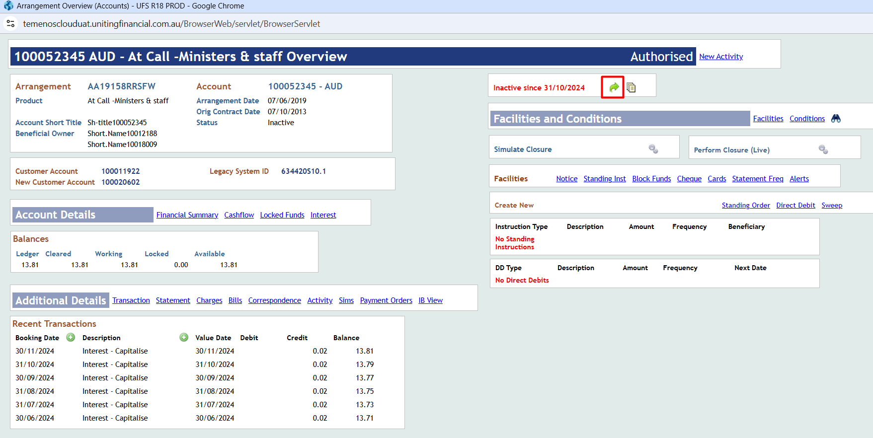

2

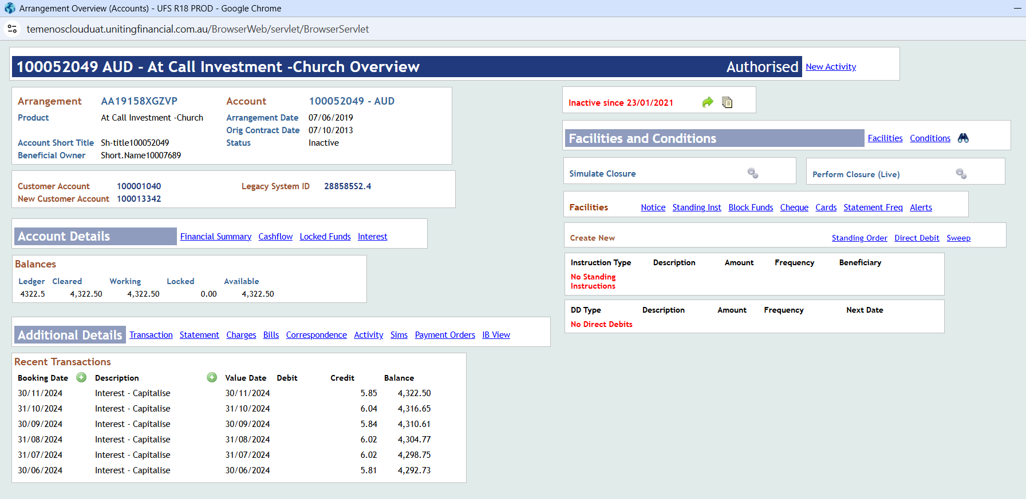

Account Audit Report

Customer Audit Report

